Executive Summary Report 1
Name : Raj Tank
NUID: 002988601
Date : 19/01/2022

A. A scatter plot between Sales and Temperature Data
The scatter plot is generated based on sales and temperature data.
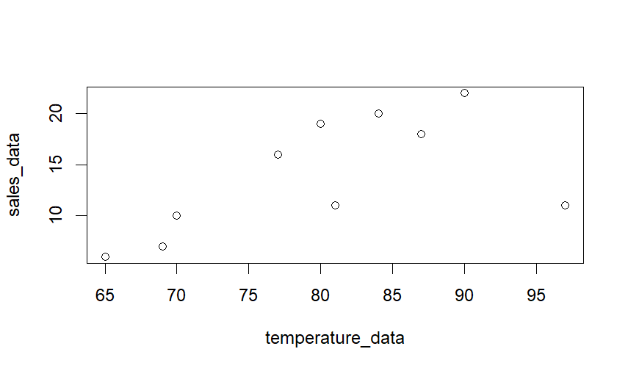

B. The mean temperature
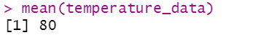
C. The sales after deleting 3rd element, and inserting 16 as 3rd element
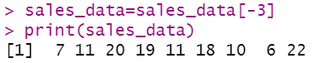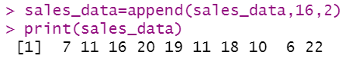
D. Display the names of vector
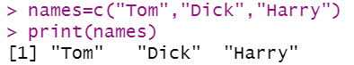

E. Displaying the five by 2 matrix
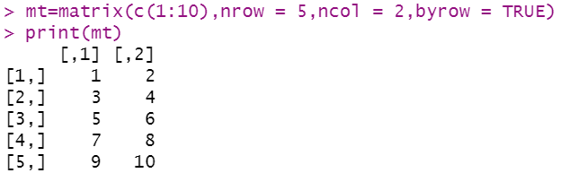
F.Displaying icSales dataframe
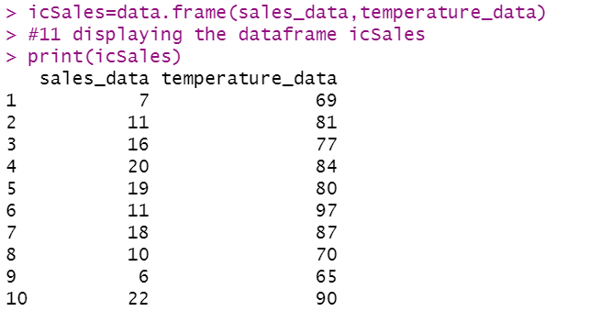
G. Displaying the summary of icSales dataframe.
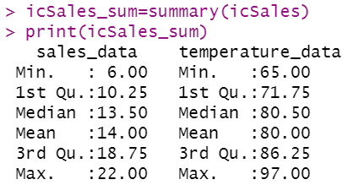
H. Displaying the variables from Student.csv
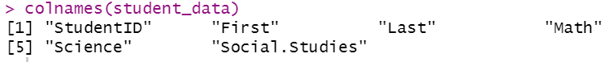

I. A summary of the information
- Initially, installed and imported the packages by install.packages(), and Library().
- The scatter plot depicts linear relationship between sales and Temperature data with few outliers.
- The summary provides descriptive statistics(Mean, median, mode, max) of the two vectors(Sales, Temperature).
- Understanding of how to load CSV file, and create data frame of icSales.
- Setting up the working directory to avoid writing the path of the file.
- Student.csv has one null values in Science subject.

Bibliography

- R in Action : Data analysis and graphics with R (Robert l. Kabacoff) https://docs.google.com/viewer?a=v&pid=sites&srcid=ZGVmYXVsdGRvbWFpbnxhZG5lc3RhZGlzdGljb3xneDo0MGY4ODg5NmE3ZjFmNThl

- How to Insert element in the middle of a vector.
https://www.geeksforgeeks.org/adding-elements-in-a-vector-in-r-programming-append-method/

- Setting up the working directory.
https://www.youtube.com/watch?v=OJ4WBjV5o1I

- R gallery for Data Visualization
https://www.r-graph-gallery.com/ggplot2-package.html

Appendix
# 1 print my name using print command
print("Raj Tank")

#2 install a package called "vcd"
install.packages("vcd")

#3 import library
library(grid)
library(vcd)

#4 plotting scatter plot
#creating two vector
sales_data=c(7,11,15,20,19,11,18,10,6,22)
temperature_data=c(69,81,77,84,80,97,87,70,65,90)
#plotting scatter plot
plot(temperature_data,sales_data)
#5 getting mean of temperature_data
mean(temperature_data)

#6 delete the third element from the sales vector
sales_data=sales_data[-3]
print(sales_data)

#7 inserting "16" in the third index
sales_data=append(sales_data,16,2)
print(sales_data)

#8 creating a vector that contains names(Tom,Dick,Harry)
names=c("Tom","Dick","Harry")
print(names)

#9 creating a 5 row and 2 columns matrix of 10 integer
mt=matrix(c(1:10),nrow = 5,ncol = 2,byrow = TRUE)
print(mt)

#10 creating a dataframe names icSales with sales and temperature
icSales=data.frame(sales_data,temperature_data)

#11 displaying the dataframe icSales
print(icSales)

#12 displaying summary of icSales
icSales_sum=summary(icSales)
print(icSales_sum)

#13 loading the dataset student csv
#need to select working directory
setwd("C:/Users/baps/Downloads")
student_data=read.csv("Student.csv")
print(student_data)

#14 print the variable in the dataset
colnames(student_data)

